NEUROANALYST-CLTM DOCUMENTATION FORM

CANDIDATE NAME: _________________________________________

- Fill out the form to log the required 50 cEEG Analyst Reports and have ABRET credentialed supervisor or medical director sign the bottom of each page.
- The candidate must be the one reviewing the long-term EEG and creating the Analyst Report.
- All recordings and Analyst Reports must be done within the last 5 years (with 10% in the last 12 months) and are only counted after the candidate obtained his/her CLTM credential.
- No more than 20% of recordings and Analyst Reports listed can be normal without patient events.
- All patients must have a birth date of age 1 year or older at the time of the recording.

CASE # | Date of Recording, Initials, & Age of Patient | Type of Recording  ICU/EMU/AMB | Was the recording Normal or Abnormal? | If abnormal, was it focal or generalized or both? | Did this record contain patient events? | Total Length of Recording (minimum of 12 hours) | Was an Analyst Report created for this patient by the candidate? Y/N

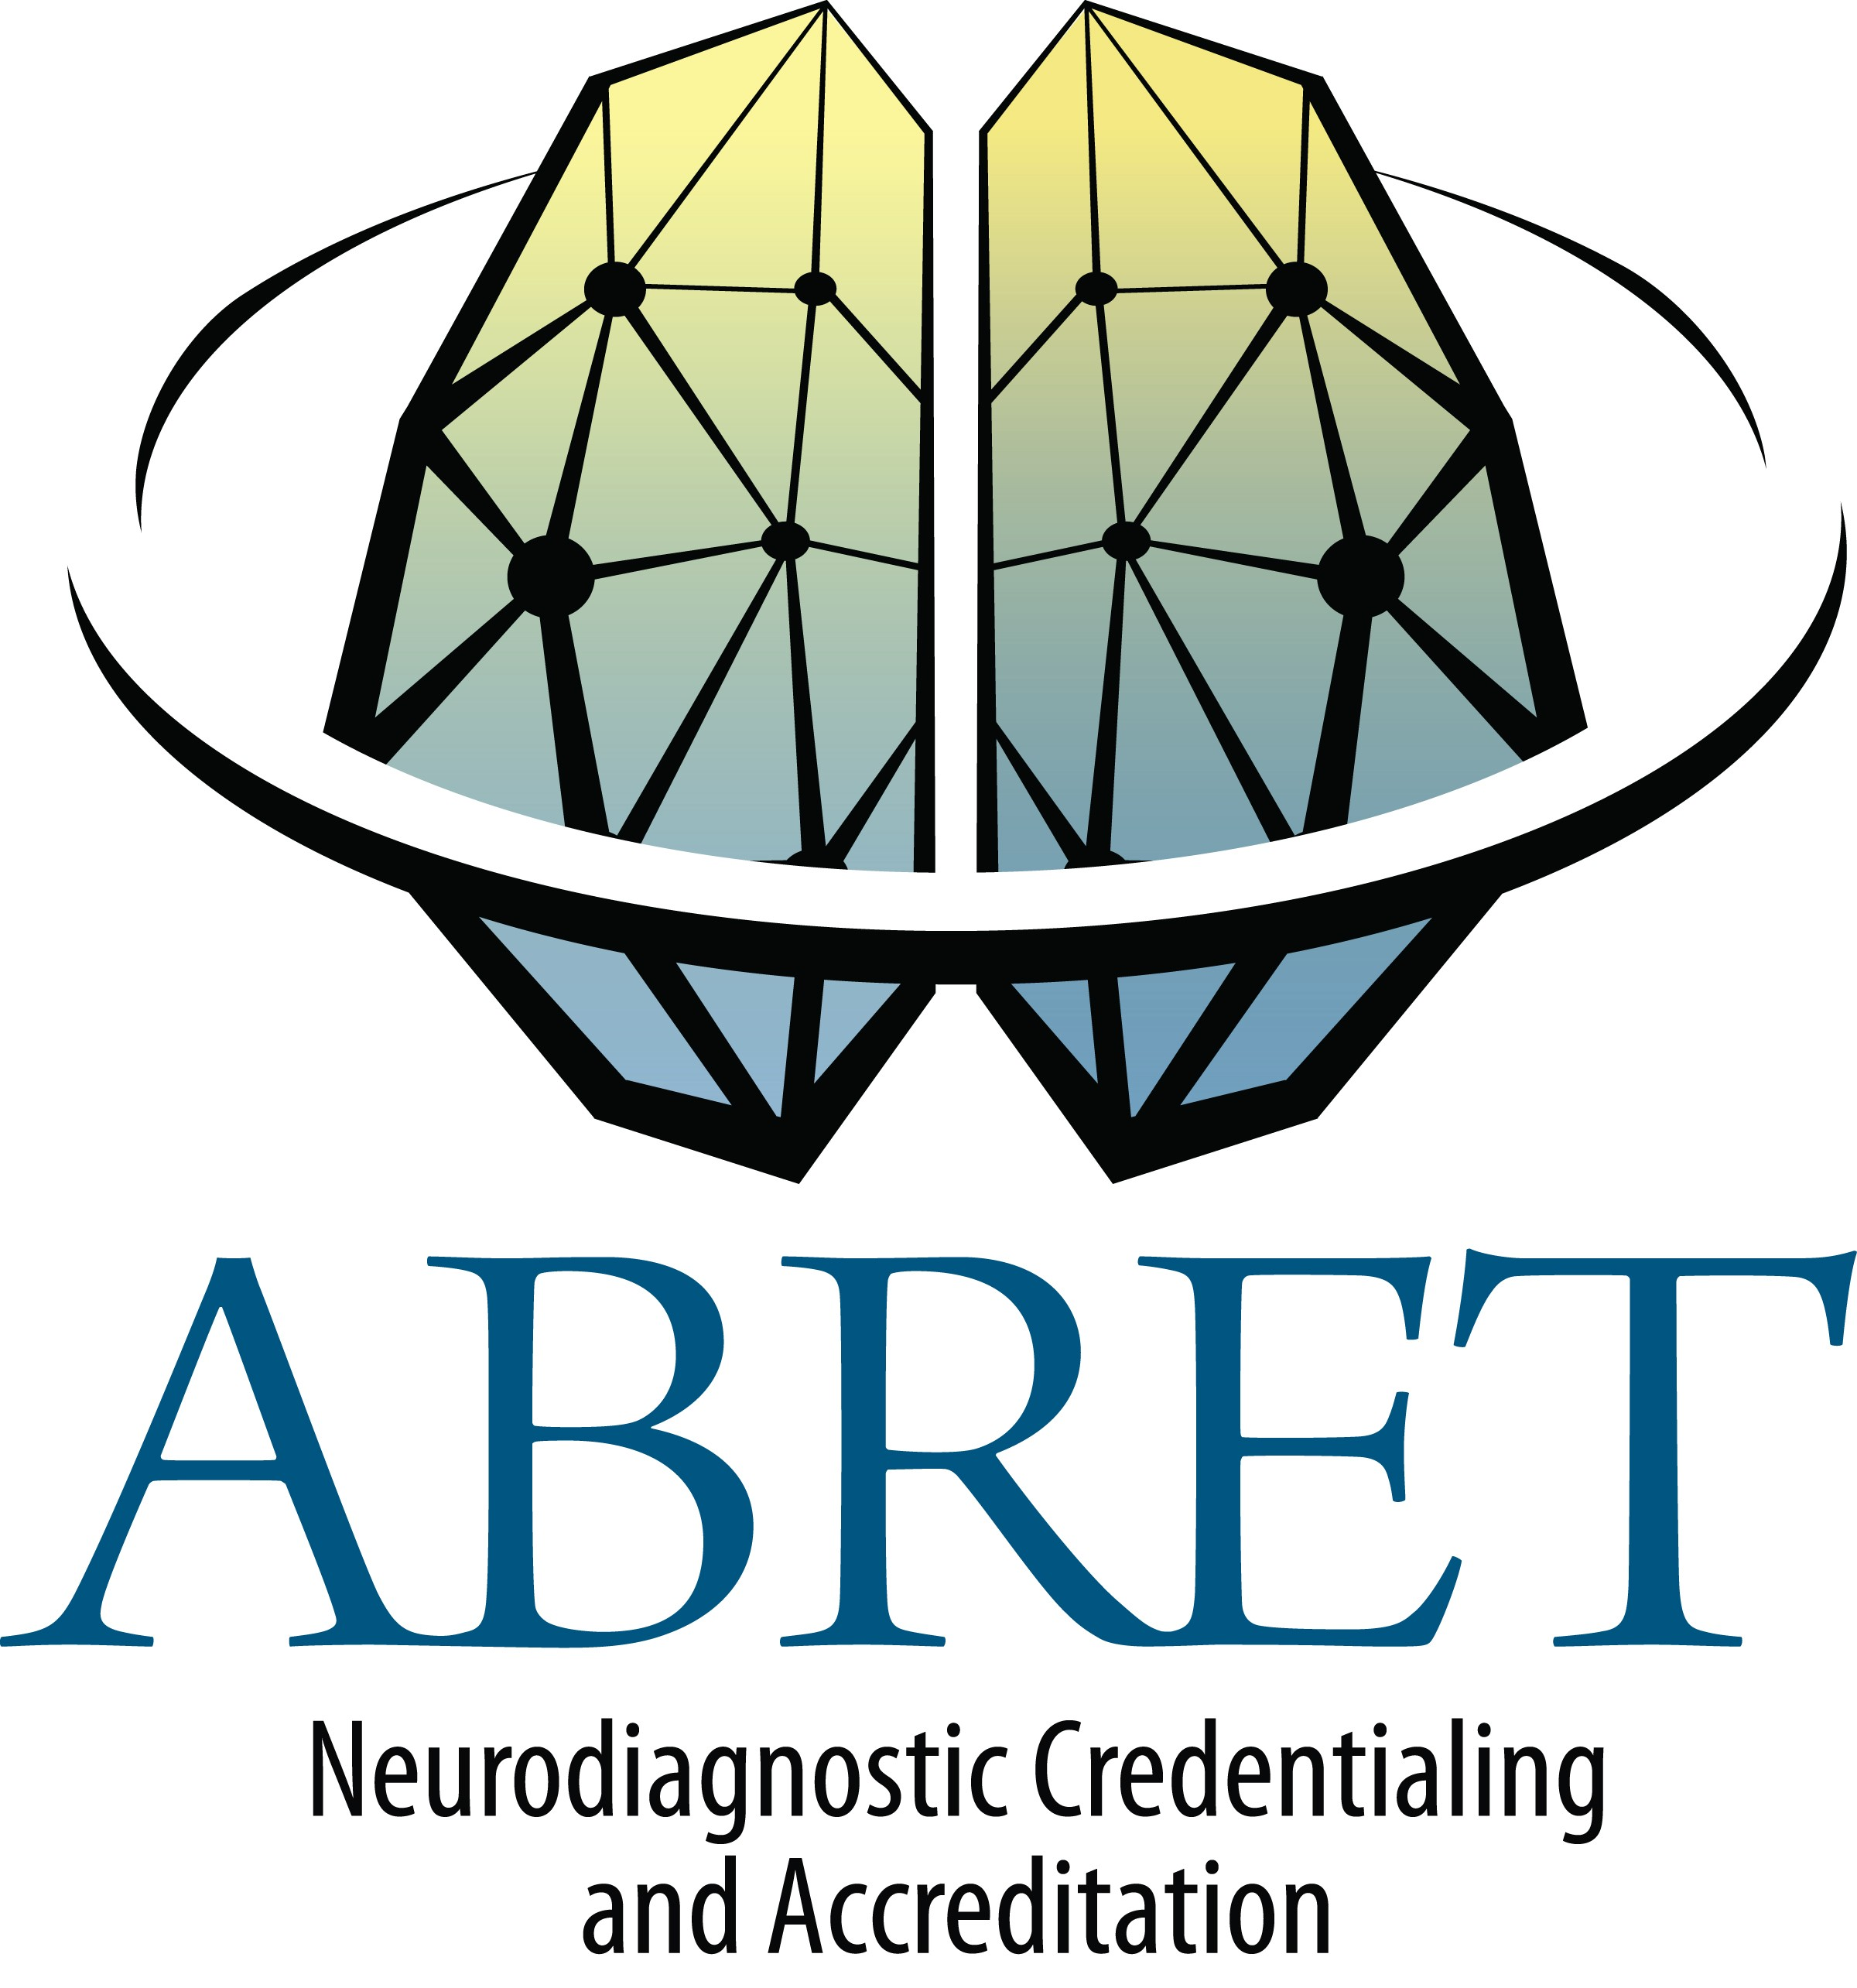
I certify that the information provided is true and accurate. Submit completed form with your application.

I recommend this candidate for the NeuroAnalyst-CLTM Exam. Random auditing will be conducted by ABRET.

Signature of Supervisor (Medical Director or ABRET Credentialed Supervisor)
page of

Print Name Clearly Phone and Email
***All form pages must be signed***

