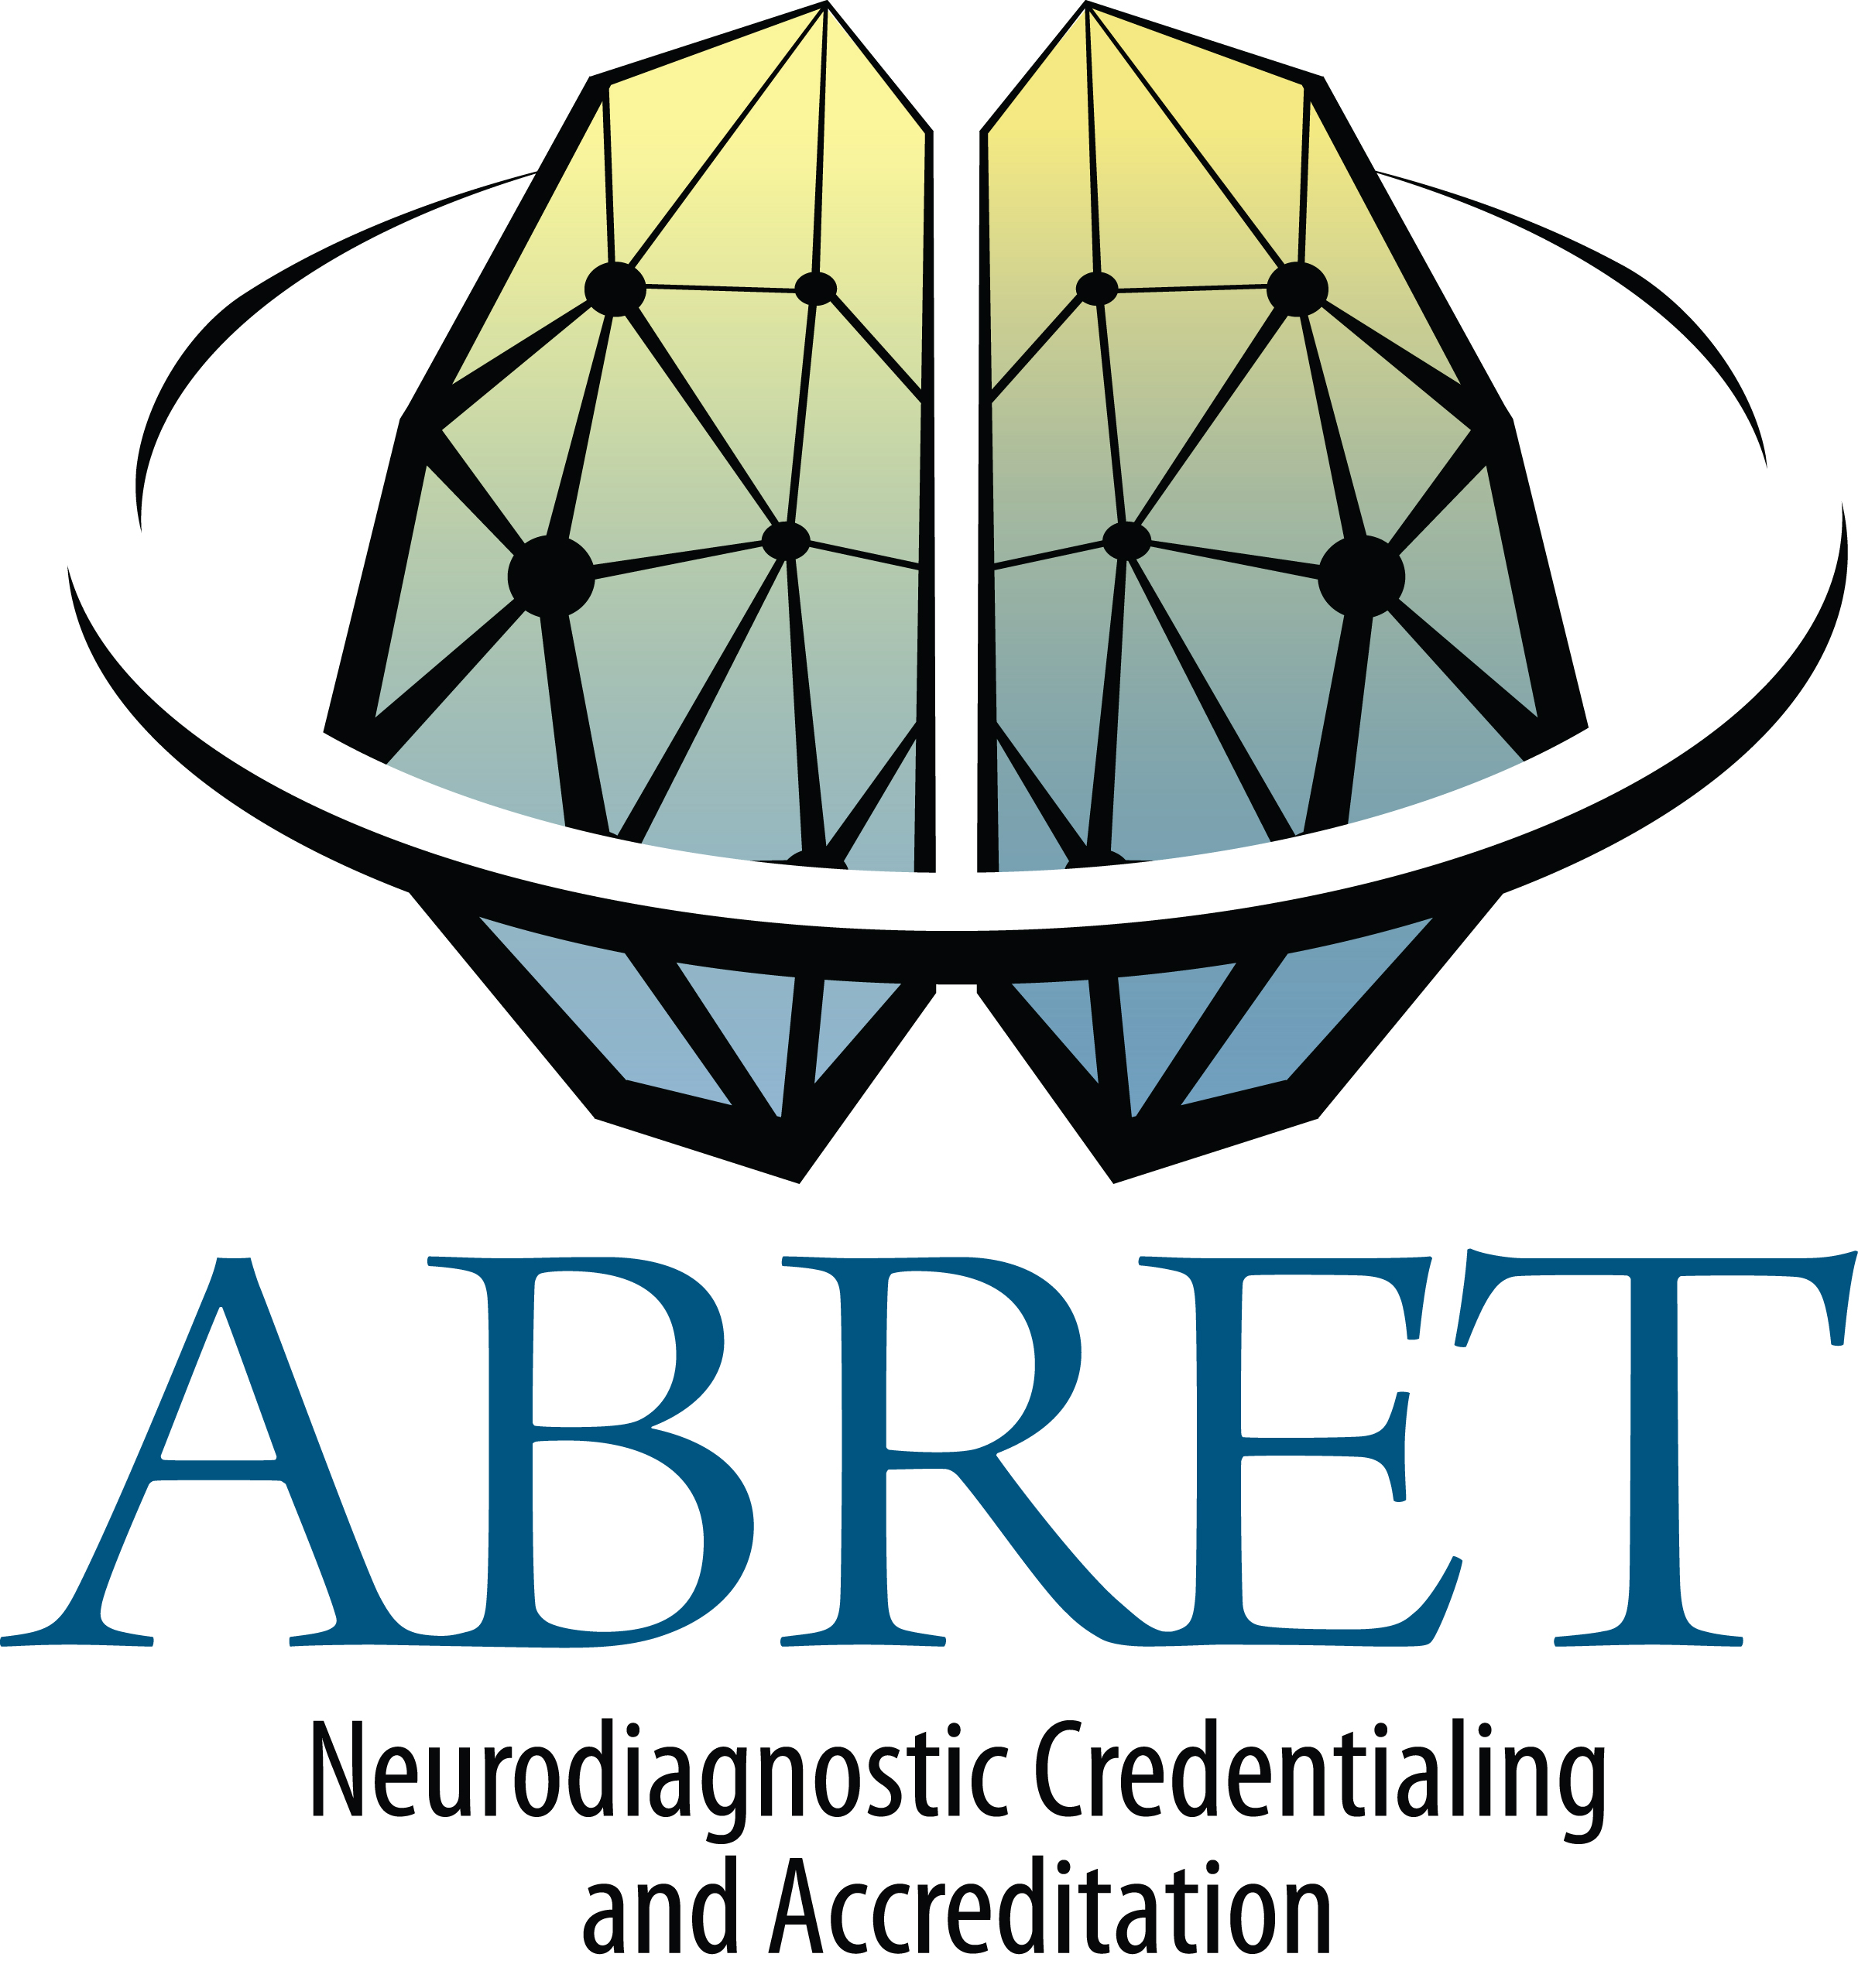
Autonomic Educational Activities
DOCUMENTATION FORM
List educational activities related to Autonomics within the last 3 years. Minimum of 3 activities required.

Candidate Name:

COURSE NAME/TOPIC | DATE(S) | LOCATION | SPONSOR | DESCRIPTION OF ACTIVITY

I understand that providing false information on this form may result in suspension or revocation of my exam eligibility.

Applicant's Signature: Date:

Upload this form along with the other required documents to your CAP Application at www.ptcyny.com/clients/abret
Incomplete forms will not be accepted.

Revised 9/2015

Activities accepted for CAP eligibility
Candidates for CAP and CAP’s submitting hours for Recertification may claim the following.
1 activity credit
Relevant autonomic lectures
Workshop
Journal review
Case study
Special interest article for ASET
In-house lecture at department/lab meeting
4 record review sessions with a physician
3 activity credits
Poster with relevant content
Platform Presentation on autonomic testing/related focus
Up to 12 activity credits
Multiple-day workshop
Annual meeting/course with autonomic focus

