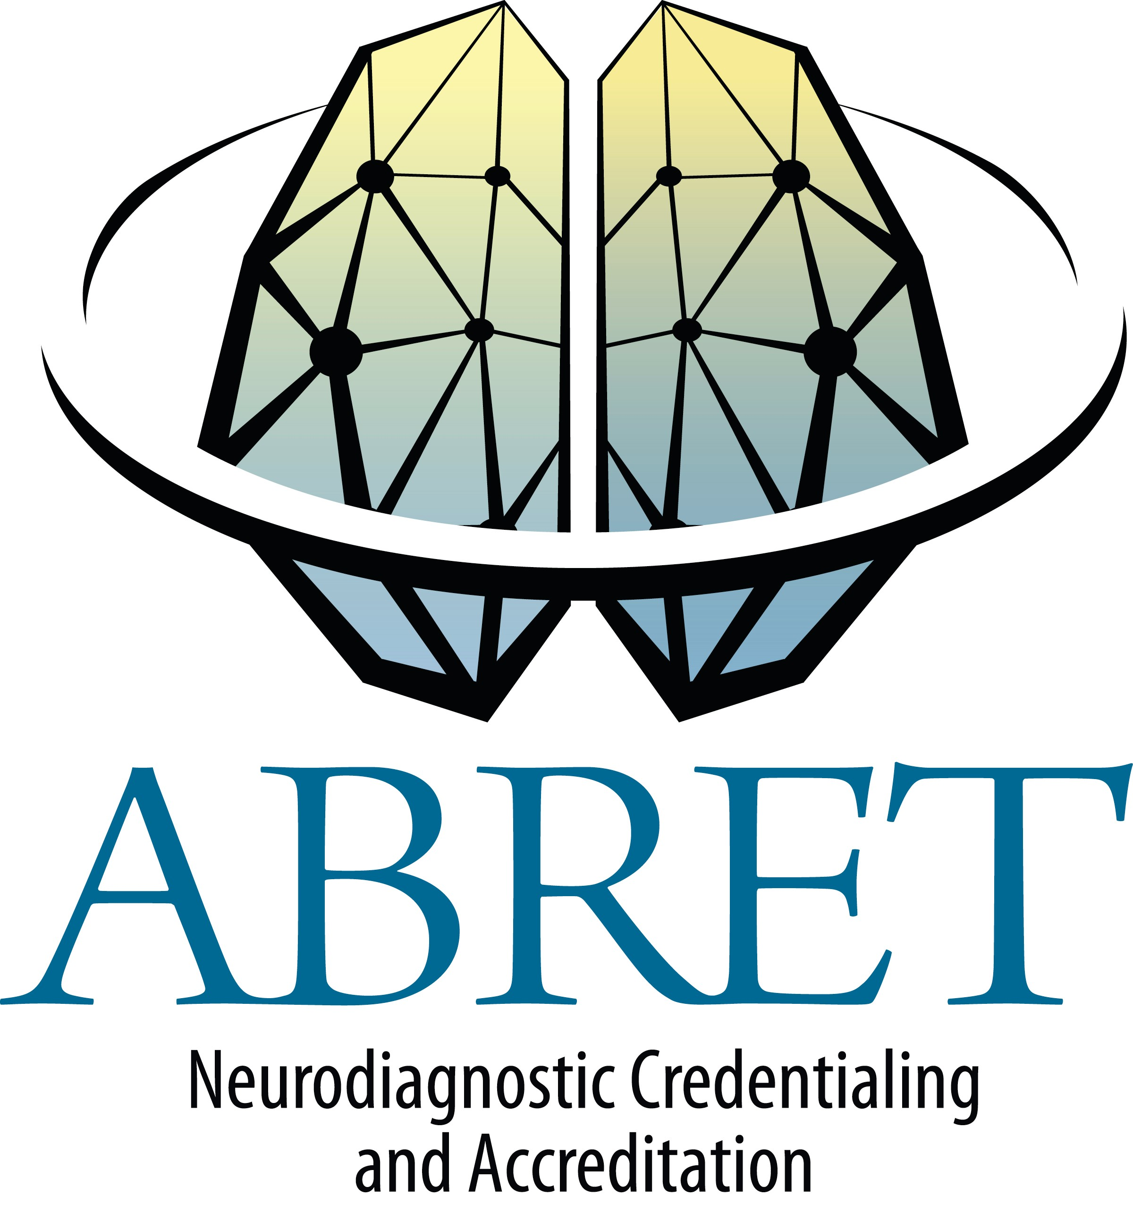
CNIM & EP EDUCATION DOCUMENTATION FORM

List 15 hours of related education hours earned in the last five years. Approved education providers are ASET, ACNS and ASNM. No more than 8 hours may be from ASET journal quizzes.

Candidate Name:

COURSE NAME/TOPIC | DATE(S) | LOCATION | SPONSOR | DESCRIPTION OF ACTIVITY | CEUs/Credits

I understand that providing false information on this form may result in suspension or revocation of my exam eligibility.

Applicant's Signature: Date:

Upload this form along with the other required documents to your CNIM application through Credential Manager on the ABRET website. Incomplete forms will not be accepted.

Revised 9/2016

