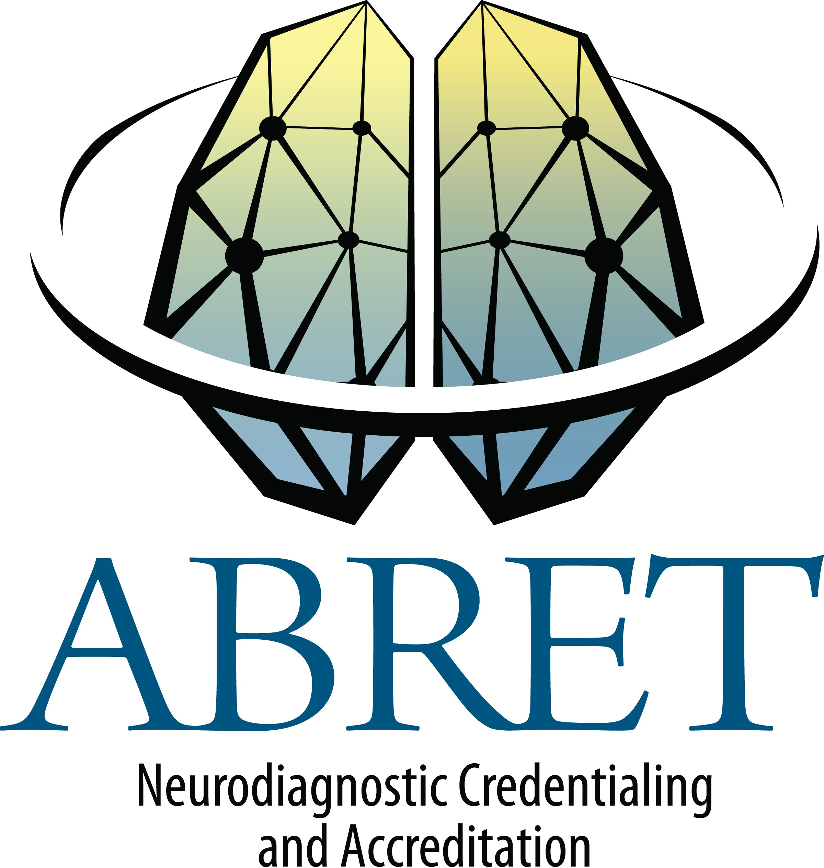
CNIM & EP EDUCATION DOCUMENTATION FORM
List 30 hours of related education hours earned in the last five years. Approved education providers are ASET, ACNS and ASNM. No more than 15 hours may be from ASET journal quizzes.

Candidate Name:

COURSE NAME/TOPIC | DATE(S) | LOCATION | SPONSOR | DESCRIPTION OF ACTIVITY | CEUs/Credits
I understand that providing false information on this form may result in suspension or revocation of my exam eligibility.

Applicant's Signature: Date:

Upload this form along with the other required documents to your CNIM application through Credential Manager on the ABRET website. Incomplete forms will not be accepted.

Revised 9/2016

